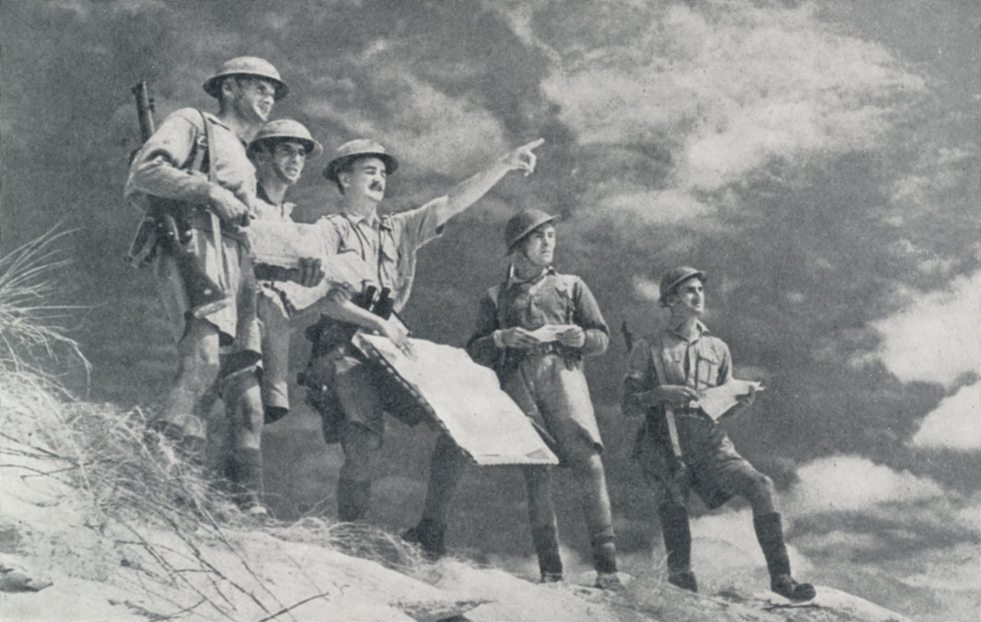

<https://www.forces-war-records.co.uk/galleries/world-war-two-army-personnel/2127>

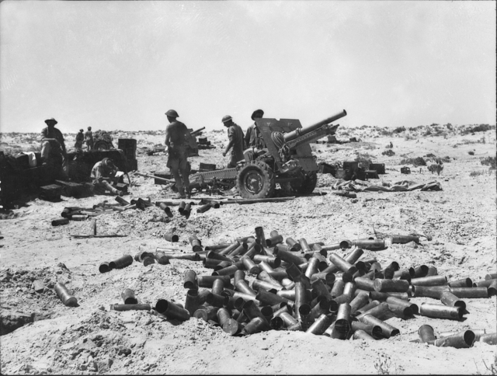

<https://en.wikipedia.org/wiki/File:2-8_Field_Regt.jpg>

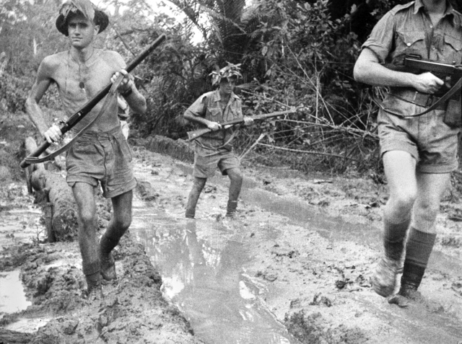

<https://en.wikipedia.org/wiki/File:Australian_troops_at_Milne_Bay.jpg>

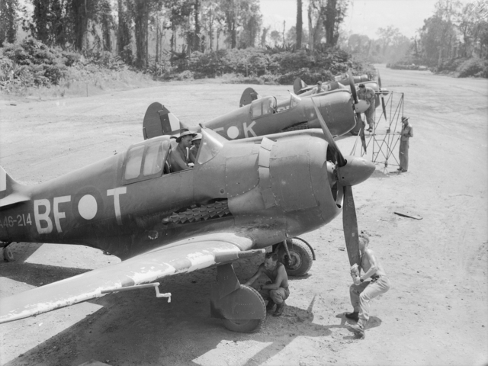

<https://en.wikipedia.org/wiki/File:Boomerangs_Bougainville_OG2064.jpg>

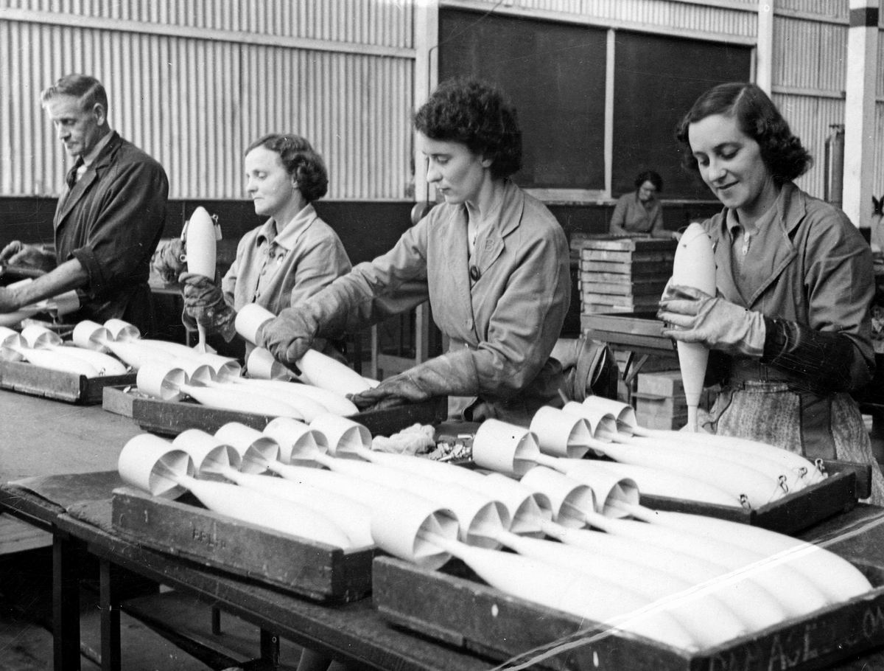

<https://en.wikipedia.org/wiki/File:Inspecting_RAAF_practice_bombs.jpg>

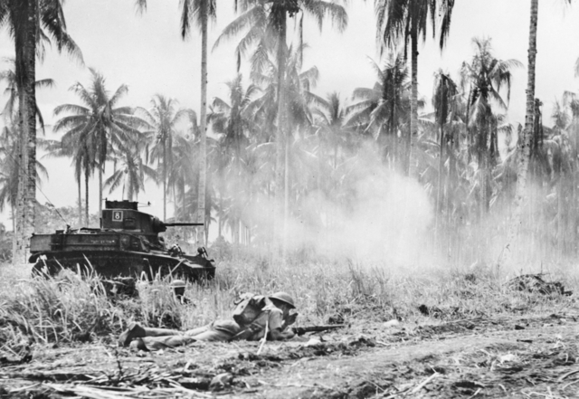

<https://en.wikipedia.org/wiki/File:M3_Light_Tanks_assault_on_Buna.jpg>

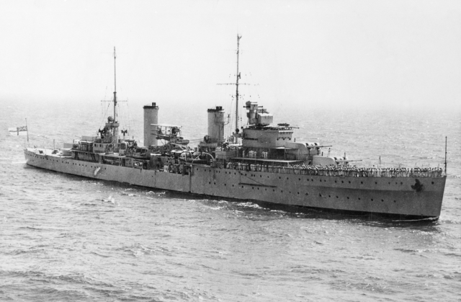

<https://en.wikipedia.org/wiki/File:HMAS_Sydney_(AWM_301473)_cropped.jpg>

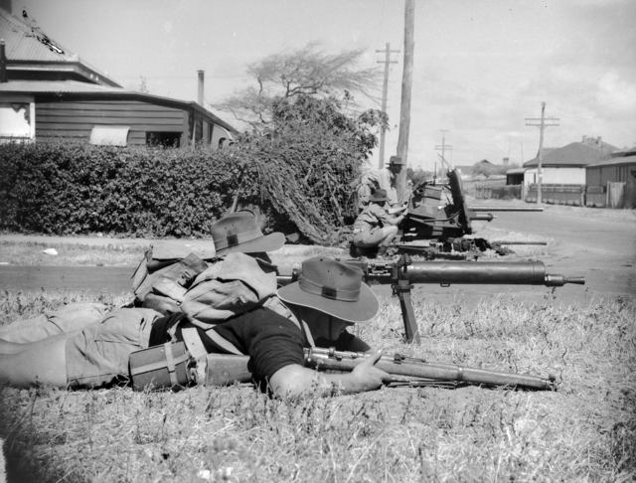

<https://en.wikipedia.org/wiki/File:Geraldton_exercise_1942_(028696).jpg>

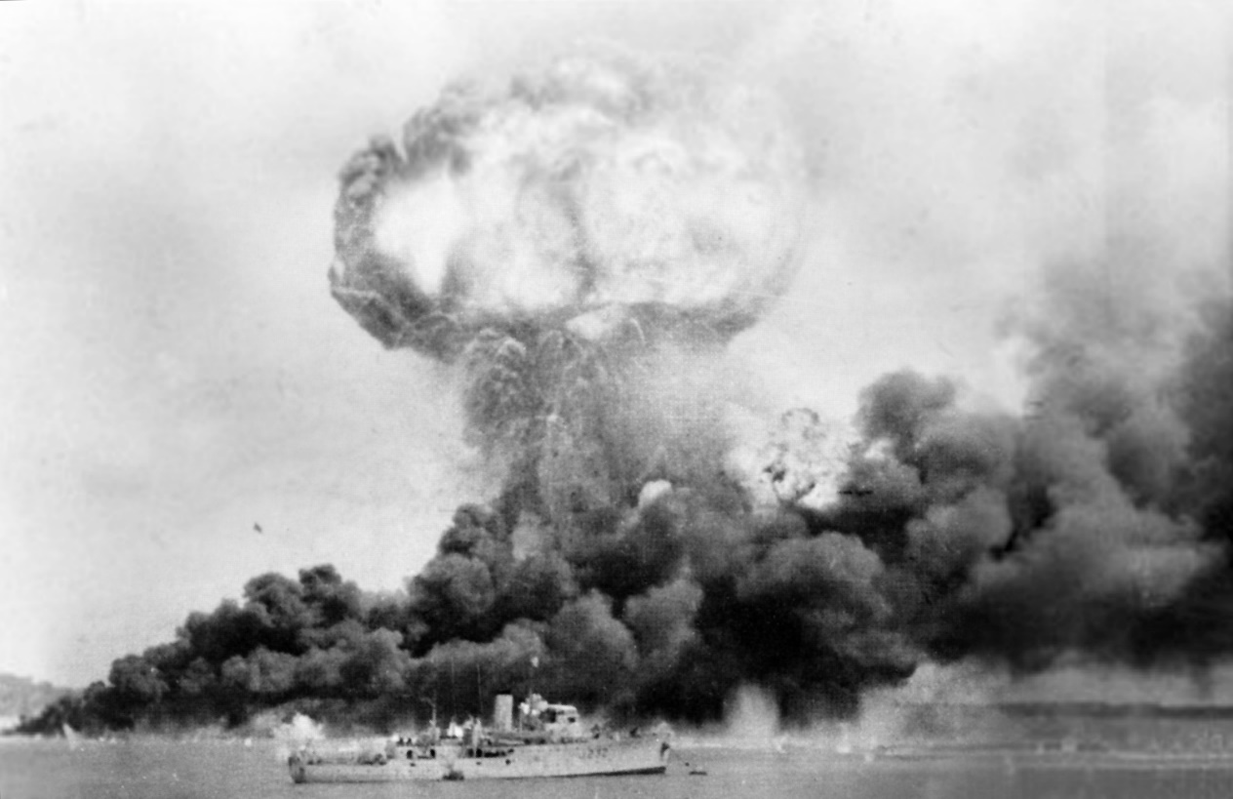

<https://en.wikipedia.org/wiki/File:Darwin_42.jpg>

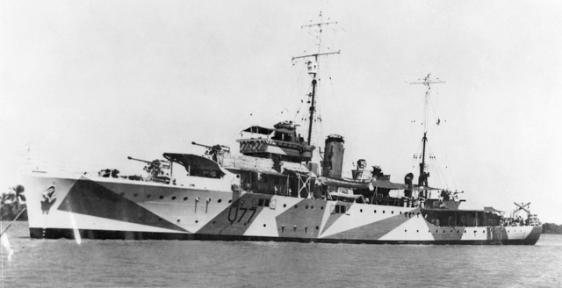

<https://en.wikipedia.org/wiki/File:HMAS_Yarra_(AWM_016263).jpg>